
National University of Sciences & Technology (NUST) Balochistan Campus (NBC), Department of Computer Science
Computer Science Department
CS-250: Data Structure and Algorithms
Class: BSCS Fall 2022
Lab 2: Implementation of Linked List with its Operations
Date: 25th September, 2024
Time: 10am - 1 pm
Lab Engr: Safder Ali

NAME | SAMEER TALREJA
CMS ID | 457795
DEPARTMENT | BS COMPUTER SCIENCE
SEMESTER | 3RD

CS250: Data Structures and Algorithms Page 1

National University of Sciences & Technology (NUST) Balochistan Campus (NBC), Department of Computer Science
Lab 2: Implementation of Linked List with its Operations
Introduction
Students have learned the fundamental concepts of linked lists in the lectures. This lab will introduce students with the practical implementation of a linked list and different operations that can be performed on a linked list.
Objectives
Objective of this lab is to get familiar with singly linked list and implement them in C++.
Tools/Software Requirement
Visual Studio C++
Helping Material
Lecture slides. Text book.
Description
Singly Linked List
A Linked List is a data structure consisting of a group of nodes which together represent a sequence. Under the simplest form, each node is composed of two parts i.e. data part and a reference part (also known as, a link) to the next node in the sequence. This structure allows efficient insertion or removal of elements from any position in the sequence.
The basic operation consist of
• Creating the list.
• Initialize pointers to NULL.
CS250: Data Structures and Algorithms Page 2

National University of Sciences & Technology (NUST)
Balochistan Campus (NBC), Department of Computer Science • Inserting nodes at beginning, last and from a specific location.
• Deletion of nodes from beginning, last and from a specific location.
• Traversing the list.
• Destroying the list.
Lab Tasks
Write a C++ program that can
1. Create a simple linked list using functions to insert nodes at the head.
2. Make a function that can insert another node at 3rd location.
3. Make a function that can display the lists made in 1 and 2.
4. Write a function that can delete node from the linked list selected by the user. Display it as well.
5. Write a function that can count the number of nodes present in list.
6. Create menu in main function to give call to all of the above functions depending upon user’s input.
Important Note: Please note that you have to develop your solution in C++ (OOP) i.e. using classes and objects. Solution written in a procedural style will not be accepted.
Hint: First you will create the relevant classes, and the functions will belong to the List class. //class of node
class Node {
public:
int value;
node *next;
};
Required functions for list class are:
void insertAtHead(int new_value);
void insertAtLocation(int location,int new_value)
void delete(int del_value)
void displayList()
void countList()
Solution:
Solution
Task 1 Code:
#include <iostream>
using namespace std;

class List {
private:
struct Node {
int value;
Node* next;
};
Node* head;

public:
List() : head(nullptr) {}

~List() {
while (head != nullptr) {
Node* temp = head;
head = head->next;
delete temp;
}
}

void insertAtHead(int new_value) {
Node* newNode = new Node;
newNode->value = new_value;
newNode->next = head;
head = newNode;
}

void insertAtLocation(int location, int new_value) {
if (location == 1) {
insertAtHead(new_value);
return;
}
Node* temp = head;
for (int i = 1; i < location - 1 && temp != nullptr; i++) {
temp = temp->next;
}
if (temp == nullptr) {
cout << "Location out of range" << endl;
return;
}
Node* newNode = new Node;
newNode->value = new_value;
newNode->next = temp->next;
temp->next = newNode;
}

void deleteNode(int del_value) {
if (head == nullptr) return;
if (head->value == del_value) {
Node* temp = head;
head = head->next;
delete temp;
return;
}
Node* temp = head;
while (temp->next != nullptr) {
if (temp->next->value == del_value) {
Node* nodeToDelete = temp->next;
temp->next = temp->next->next;
delete nodeToDelete;
return;
}
temp = temp->next;
}
}

void displayList() {
Node* temp = head;
while (temp != nullptr) {
cout << temp->value << " ";
temp = temp->next;
}
cout << endl;
}

void countList() {
int count = 0;
Node* temp = head;
while (temp != nullptr) {
count++;
temp = temp->next;
}
cout << "Number of nodes: " << count << endl;
}
};

int main() {
List myList;
int choice;
while (true) {
cout << "1. Insert at head" << endl;
cout << "2. Insert at location" << endl;
cout << "3. Delete node" << endl;
cout << "4. Display list" << endl;
cout << "5. Count nodes" << endl;
cout << "6. Exit" << endl;
cout << "Enter your choice: ";
cin >> choice;
switch (choice) {
case 1: {
int new_value;
cout << "Enter new value: ";
cin >> new_value;
myList.insertAtHead(new_value);
break;
}
case 2: {
int location, new_value;
cout << "Enter location: ";
cin >> location;
cout << "Enter new value: ";
cin >> new_value;
myList.insertAtLocation(location, new_value);
break;
}
case 3: {
int del_value;
cout << "Enter value to delete: ";
cin >> del_value;
myList.deleteNode(del_value);
break;
}
case 4:
myList.displayList();
break;
case 5:
myList.countList();
break;
case 6:
return 0;
default:
cout << "Invalid choice" << endl;
}
}
return 0;
}

Task 1 Output Screenshot:
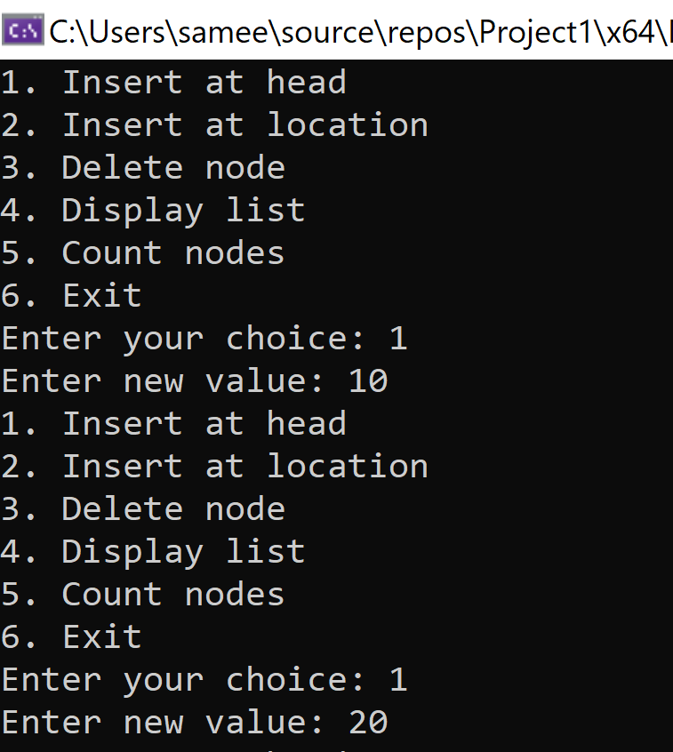

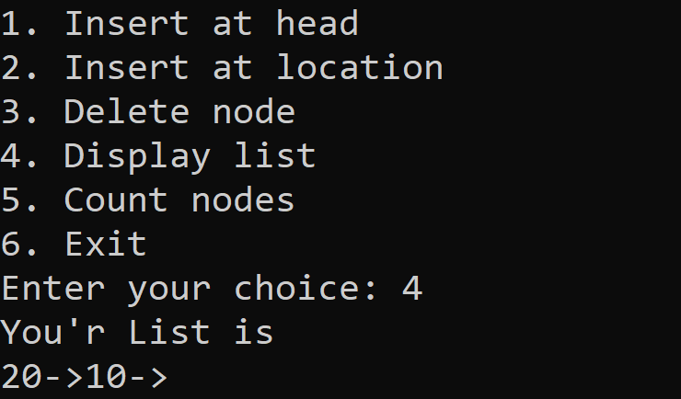

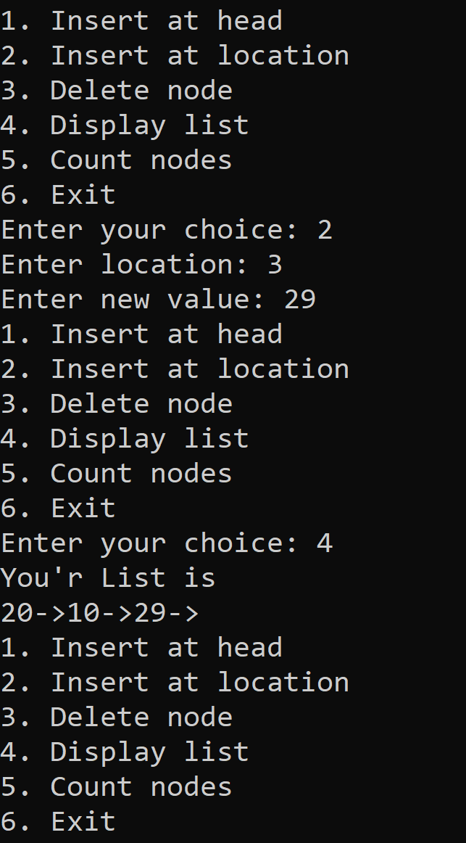

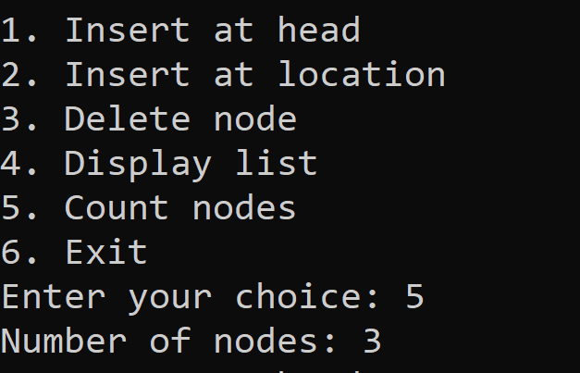

CS250: Data Structures and Algorithms Page 3

National University of Sciences & Technology (NUST) Balochistan Campus (NBC), Department of Computer Science
Deliverables
Compile a single word document by filling in the solution part and submit this Word file on LMS/Google Classroom. This lab grading policy is as follows: The lab is graded between 0 to 10 marks. The submitted solution can get a maximum of 5 marks. At the end of each lab or in the next lab, there will be a viva related to the tasks. The viva has a weightage of 5 marks. Insert the solution/answer in this document. You must show the implementation of the tasks in the designing tool, along with your complete Word document to get your work graded. You must also submit this Word document on the LMS/Google classroom. In case of any problems with submissions, submit your Lab assignments by emailing it to Mr. Safder Ali students.em96@gmail.com
CS250: Data Structures and Algorithms Page 4

